Q.1 What is JavaScript. How to use it?

A -1 JavaScript is a programming language of web. JavaScript can update and change both html and CSS. JavaScript can calculate manipulate the data.

When we can use the JavaScript in html employing the dedicated html tag<script> that wraps around JavaScript codes.

JavaScript link is in the head tag and script tag are before the close body tag.

Q.2 How many types of Variables in JavaScript?

A-2 There are three types of variables in JavaScript

* Var
* Let
* const

Q.3 Define a Data Types in js?

A-3 data types in javascript define a data type is a variable cane store.

There are two types of data types

Primitive datatype

* String
* Number
* Bullion
* Null
* Undefined

Non primitive data type

* Object
* Array
* Time

Q.4 Write a null Function Which will Work Properly When invoked With Following Syntax.

A-4 function sum(a,b) { return a + b; }

var result = sum.call(null,3,4);

Q.5 What the deference between undefined and undeclare in JavaScript?

A-5 the deference between undefined and undeclare in JavaScript is undefined variable means a variable has been declared but does not have a value. Undeclared variable means that the variable does not exists at the prograame at all.

Q.6 Using console.log() print out the following statement: The quote 'There is no exercise better for the heart than reaching down and lifting people up.' by John Holmes teaches us to help one another. Using console.log() print out the following quote by Mother Teresa:

A-6

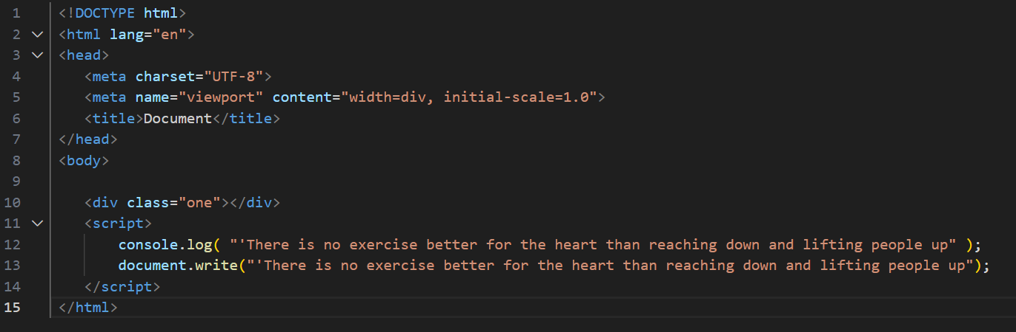

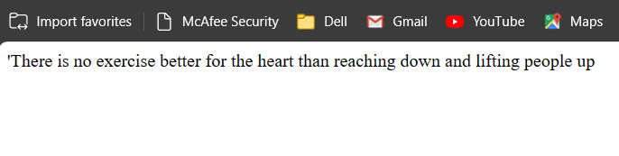

Q.7 Check if type of '10' is exactly equal to 10. If not make it exactly equal?

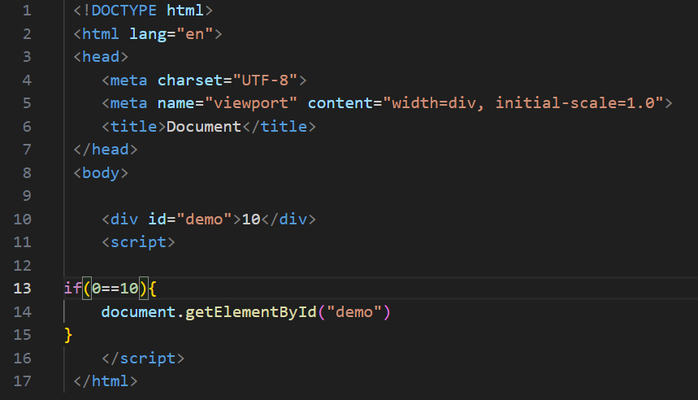

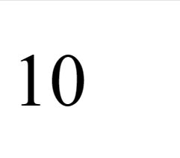

Q.8 Write a JavaScript Program to find the area of a triangle?

A-8 area = (base \* height) / 2

function triangle Area(base, height) {

return 0.5 \* base \* height;

}

// Example usage

let baseLength = 10;

let heightLength = 5;

let area = triangleArea(baseLength, heightLength);

console.log(`The area of the triangle is: ${area}`);

Q.9 Write a JavaScript program to calculate days left until next Christmas?

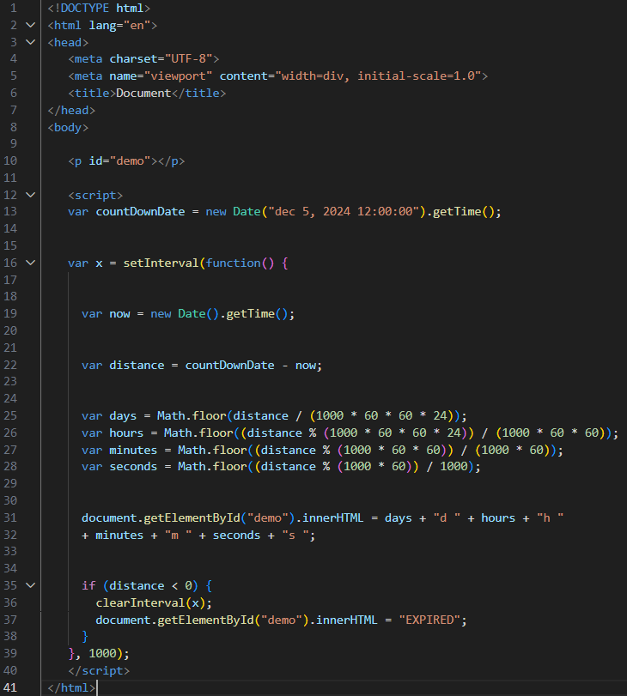

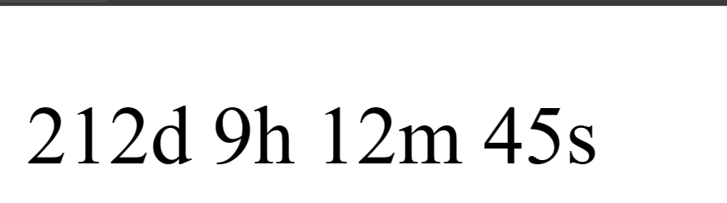

Q.10 What is Condition Statement?

A-10 in computer science condition are programming language command for handling decision specifically condition perform different computation or action depanding on whether a programmer defined Boolean condition evaluate to true or false.

Q.11 Find circumference of Rectangle formula: C = 4 \* a ?

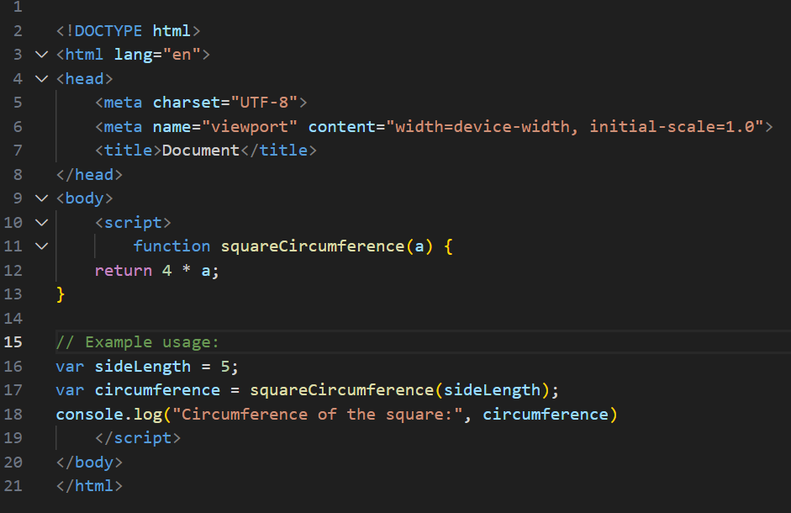

Q.12 WAP to convert years into days and days into years?

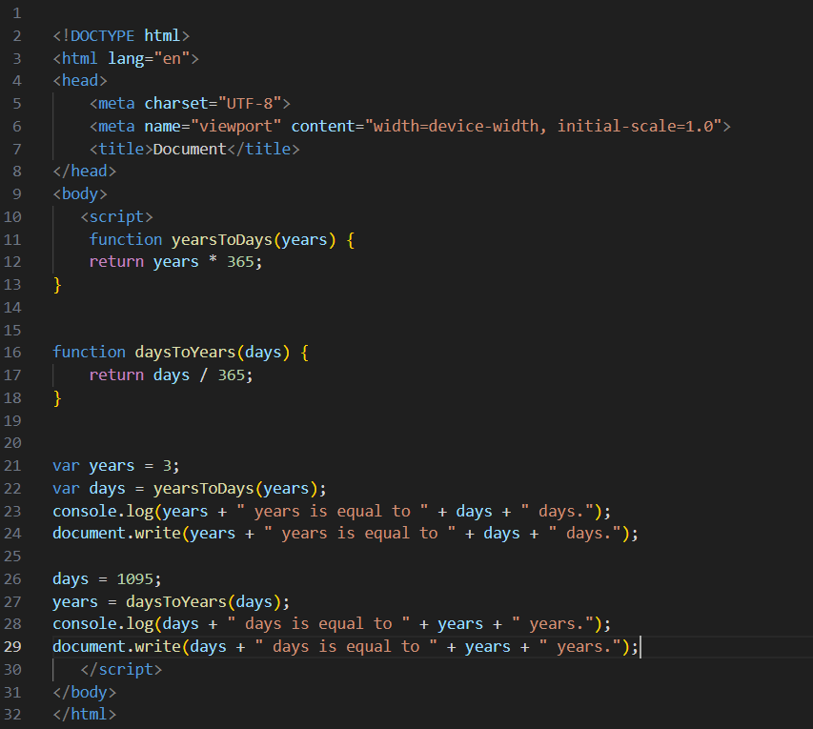

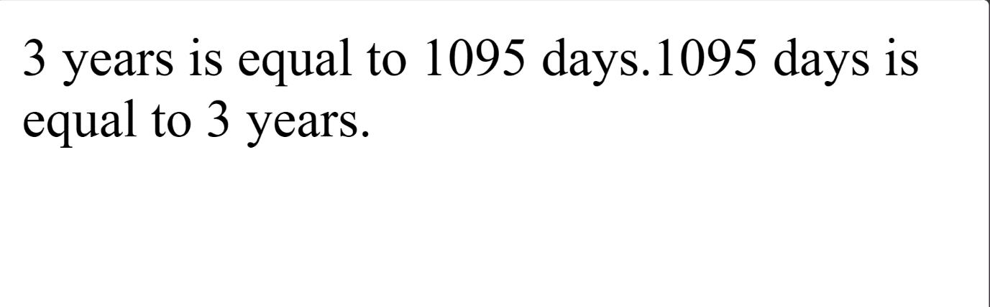

Q.13 Convert temperature Fahrenheit to Celsius?

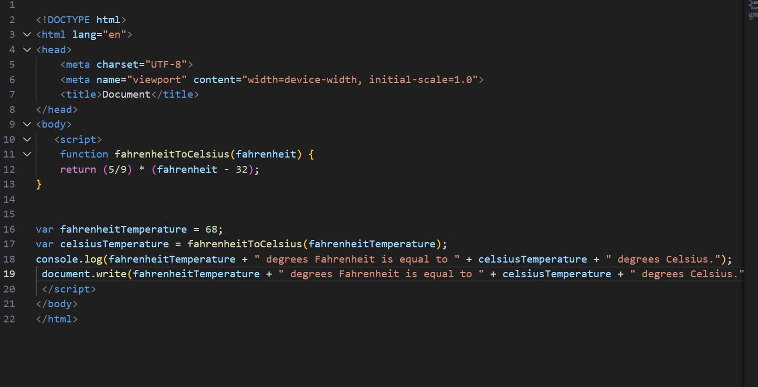

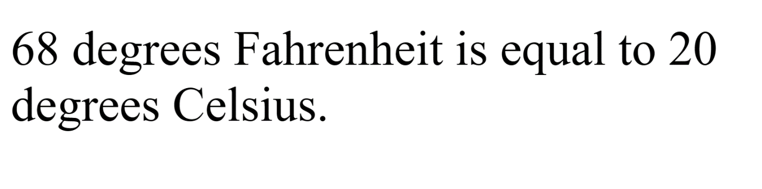

Q.14 Write a JavaScript exercise to get the extension of a filename.?

A-14

* Visual presentation
* Sample presentation

Q.15 What is the result of the expression (5 > 3 && 2 < 4)?

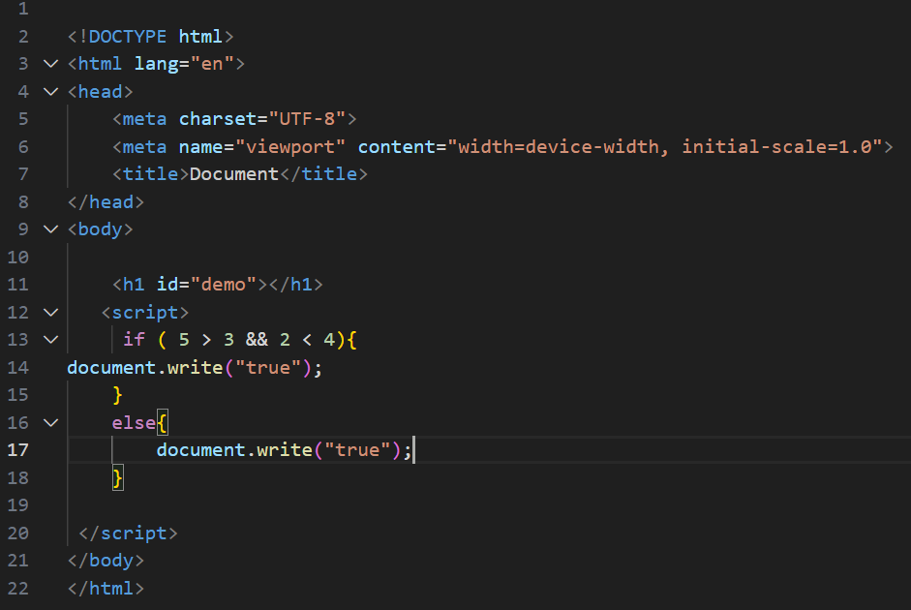

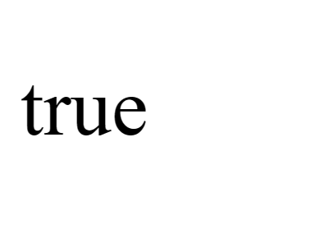

Q.16 What is the result of the expression (true && 1 && "hello")?

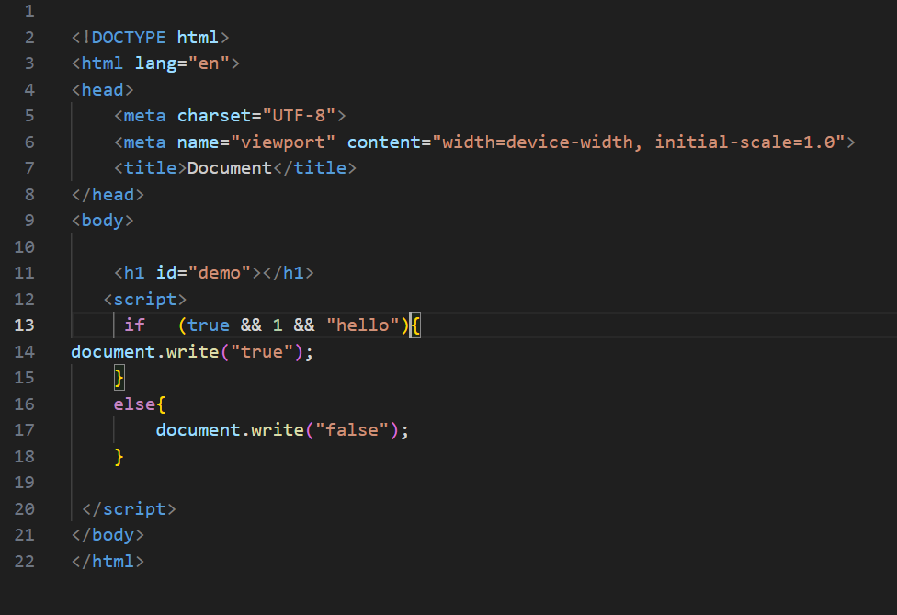

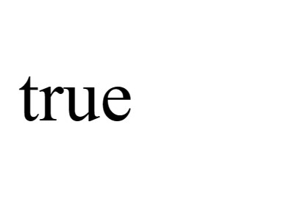

Q.17 What is the result of the expression true && false || false && true?

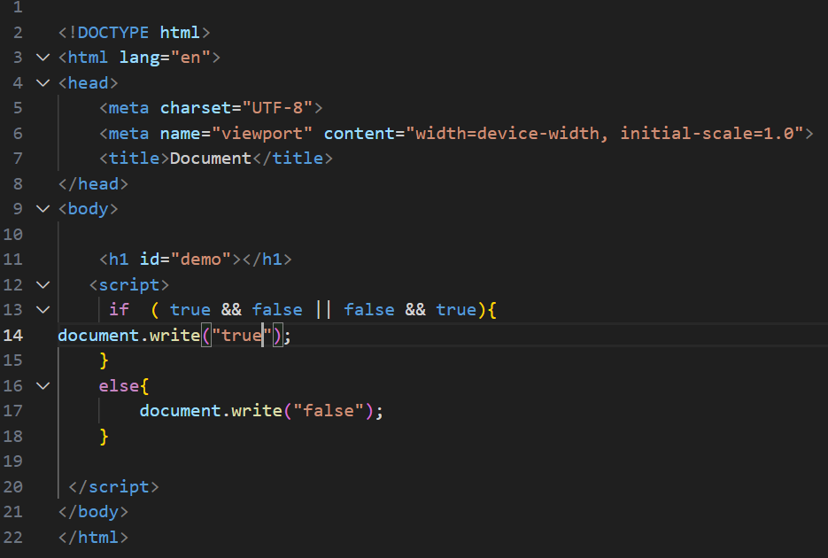

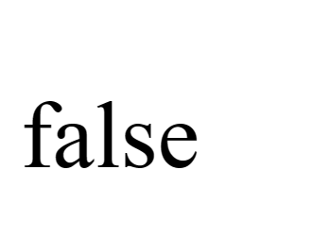

Q.18 What is a Loop and Switch Case in JavaScript define that?

A-18 JavaScript loops are powerful loops for performing repetitive task efficiency.

There are three types of loop in JavaScript

* For loop
* Do loop
* While loop

The switch statement evaluates an expression matching the expression value against a series of case clauses and executes statements after the first case clause with a matching value until a break statement is encountered.

Q.19 What is the use of is Nan function?

A-19 in the JavaScript nan is a short for not a number. the nan () method returns true if a value in nan () methods convert the value toa number before testing it.

Q.20 What is the difference between && and || in JavaScript?

|| means “or” ,it evaluates to true if the expression on the either side is truthly,&& “and “it evaluates to false if the expression on either side is false.

Q.21 What is the use of Void (0)?

A-21 the void operator evaluates an expression and undefined by running void (0) in the URL JavaScript code nothing is evaluated or returned.

Q.22 Check Number Is Positive or Negative in JavaScript?

A-22

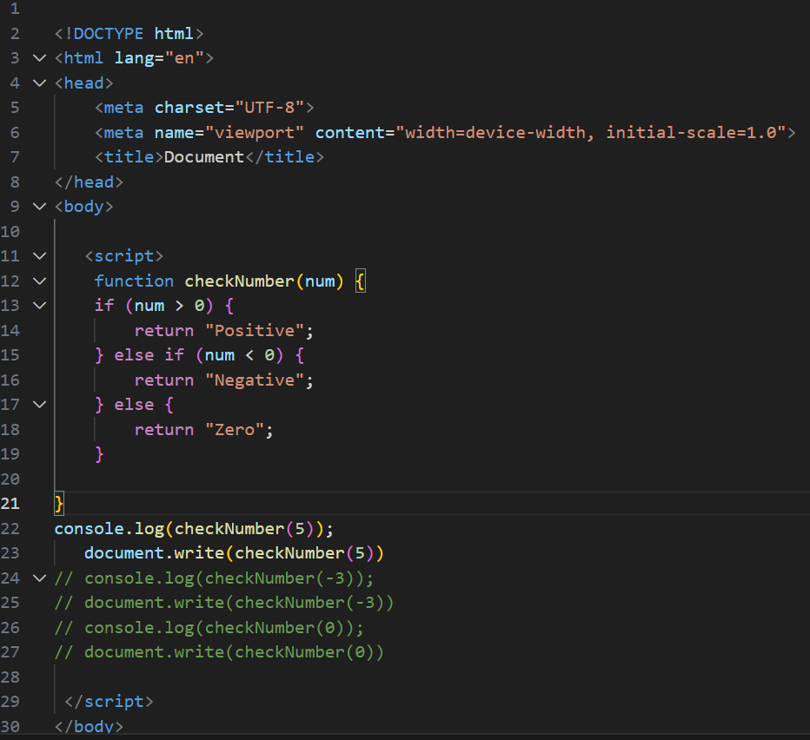

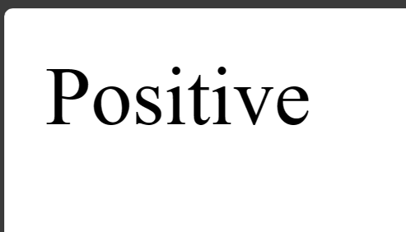

Q.23 Find the Character Is Vowel or Not ?

A-23 function is vowel if (character== a,e,I,ou A,E,I,O,U

{return true}

Else {return false}

If it is a vowel and it’s the first element.